2023 Spring CSIT 214 - IT Project Management

Group Assignment

Title:

FlyDreamAir Flight Online Service

**Done By : NEW GROUP**

|  |  |  |
| --- | --- | --- |
| Student ID | Name | Signature |
|  | Rana Muhammad Mateen | Rana Muhammad Mateen |
|  | Arnav Aryal | Arnav Aryal |
|  | Ethan Naughton | Ethan Naughton |
|  | Royce Bennett | Royce Bennett |
| 7937738 | Low Chun Tai | Low Chun Tai |

### **Introduction**

FlyDreamAir is a major airline which covers both international and domestic routes with a large fleet of aircrafts. FlyDream is planning to digitalize the business and operations, in order to upgrade the customer service experience.

### **Justification**

After careful consideration, our group has chosen to work on "Project 1". We have come to this conclusion through a thorough process of SWOT analysis. This method is particularly helpful in evaluating the Strengths, Weaknesses, Opportunities, and Threats of a project to make an informed decision. The outcome of the SWOT analysis is discussed below:

**Strengths:**

1. Competitive advantage: FlyDream Air has the potential to gain a competitive edge by offering such a convenient booking and management system.
2. Efficiency in operations: the project could lead to more efficient processing of bookings and booking management. It allows these processes to be automated and hence saves time and man hours.
3. Improved Customer Experience: a user-friendly app that offers the convenience of performing menial tasks at the tap of a button will be greatly appreciated by the customer.

**Weaknesses:**

1. **Initial Investment:** Developing this software will require a somewhat large investment at first.
2. **Security Concerns:** Security and data privacy problems may arise while storing customer's personal information and payment information.

**Opportunities:**

1. **Customer Retention:** the software can support and promote customer loyalty programs. Providing points or rewards to frequent customers may make them more likely to fly with the company more often.
2. **Cost savings:** software like this can reduce company costs over time. It does so by reducing the amount of manual processes and administrative tasks such as check-ins and ticketing.

**Threats:**

1. **Potential CyberSecurity attacks:** software like this run the risk of facing cyber-attacks. To deal with sensitive customer data, the company must implement top quality security measures.
2. **Competition:** rival companies are likely to implement similar software. Hence, the company must make constant efforts to improve the system to stay ahead.

The SWOT analysis brings us to the conclusion, that while it may require an initial investment, and cause some challenges, the benefits it provides outweigh the possible threats. This makes it a good strategic decision for the company.

### **Business Case**

Summary:

FlyDreamAir, a prominent international and domestic airline with a substantial fleet and a vast global network, aims to enhance its operational efficiency, customer experience, and revenue generation by transitioning to a comprehensive IT software system. This software system will enable customers to seamlessly book flights, manage reservations, select seats, and purchase in-flight services. By streamlining its business processes and embracing digitalization, FlyDreamAir seeks to solidify its competitive position and achieve sustainable growth in the aviation industry.

Situation Analysis:

FlyDreamAir currently operates in a highly competitive market, serving both international and domestic routes. Its extensive fleet and wide network of travel agencies and customers signify a strong foundation. However, the airline faces challenges related to operational complexity, customer experience inconsistency, and the need for cost-effective solutions. With the industry's growing emphasis on digital engagement and customer-centric services, FlyDreamAir recognizes the urgency to transform its operations.

**Cost vs. Benefit Analysis:**

**Benefits:**

* **Enhanced Customer Experience:**

The IT software system will enable customers to conveniently book flights, manage reservations, and personalize their in-flight experience, resulting in higher customer satisfaction and loyalty.

* **Operational Efficiency:**

Digitalization will automate various manual processes, reducing errors and improving resource allocation, which ultimately leads to lower operational costs.

* **Increased Ancillary Revenue:**

The ability to offer personalized in-flight services will likely lead to higher revenue through increased sales of food, drinks, and other services.

* **Competitive Advantage:**

Implementing cutting-edge technology can differentiate FlyDreamAir from competitors, attracting tech-savvy travelers and bolstering the airline's reputation.

* **Data-Driven Insights:**

The software system will gather valuable customer data, allowing FlyDreamAir to analyze trends, preferences, and demands, leading to more informed business decisions.

**Costs:**

* **Development and Implementation Costs:**

Initial investment will be required for software development, testing, and integration with existing systems.

* **Training and Change Management:**

Employees will need training to adapt to the new system, requiring time and financial resources.

* **Maintenance and Upkeep:**

Ongoing maintenance and updates to the software system will incur costs.

**Justification:**

The benefits of this digitization project significantly outweigh the costs. Improved customer experience, operational efficiency, and increased revenue potential provide strong justification for the investment. The evolving industry landscape and growing customer expectations necessitate such advancements to maintain competitiveness.

**Feasibility Study:**

The feasibility of this project is supported by:

* **Market Demand:**

Industry trends emphasize the need for seamless digital services, aligning with customer preferences.

* **Technological Readiness:**

The availability of advanced IT solutions and digital platforms makes implementation achievable.

* **Internal Expertise:**

FlyDreamAir can leverage its existing resources and collaborate with technology partners to ensure successful development and deployment.

* **ROI Potential:**

The project's positive impact on customer loyalty, operational efficiency, and ancillary revenue generation justifies the initial investment.

In conclusion, FlyDreamAir's digitalization project holds substantial promise. By embracing technology to enhance customer experiences and streamline operations, the airline is poised to reinforce its market position, capture new opportunities, and establish a foundation for sustained growth in the dynamic aviation industry.

### **Project Charter**

|  |  |  |  |  |  |  |  |  |  |  |  |  |  |  |  |  |  |  |
| --- | --- | --- | --- | --- | --- | --- | --- | --- | --- | --- | --- | --- | --- | --- | --- | --- | --- | --- |
| **Project Title:** Flight online service  **Date of Authorization:** August 14 (w4)    **Project Start Date:** August 18 (w4)  **Projected Finish Date:** October 19 (w12)    **Summary Schedule:**  Key schedule Milestone:  - Complete the interface idea by week 6  - Complete the first version of the product by week 10  - Complete the final version of the product by week11    **Budget Information:**  We have $1 million budget for the project, it would be mostly use for interval labor.    **Project Manager:**  Rana Muhammad Mateen, Arnav Aryal, Ethan Naughton, Royce Bennett, Low Chun Tai  (Each takes turn for a week in this order)    **Project Objectives:**  In order to provide better experience to the customers, our objectives are to create and develop a concise software system for airplane service, making it more convenient and easier to learn and use.  **Main Project Success Criteria:**  The software product must have reasonable scope, meet all the required specifications, be tested thoroughly, and completed each milestones on time.    **Approach:**   * Work on researching for more knowledge and detailed method of creating a friendly software system * Develop a work breakdown structure, Gantt chart, and scope statement * Hold weekly meetings to review progress, discuss different parts, and help each other out.   **Roles and Responsibilities:**   |  |  |  | | --- | --- | --- | | **Name** | **Role** | **Responsibilities** | | Rana Muhammad Mateen | Team member | Demonstration and evidence of the software | | Arnav Aryal | Team member | Risk management | | Ethan Naughton | Team member | Study business case | | Royce Bennett | Team member | Develop WBS and project scope statement | | Low Chun Tai | Team member | Evaluate effort/cost estimation | |

### 

### **Project Scope Statement**

FlyDreamAir wants to have a system where we can manage customers and make it easier for them to book/manage flights and having access to inflight services. A part of our aim is to ensure that customers can use our system in the most simplest way possible, but also so its easy for FlyDreamAir to manage. The software system will involve certain procedures to make the system work smoothly and to make it easier for all users. Within the system, the users will be able to look up flights, book them and be able to look at the details of the flight and where they’re sitting. Booking a seat will involve showing the available seats that are left, which would make it easier for them to decide where they want to sit. This will make it easier for the company when managing who is sitting where and what seats have been taken. When confirming bookings, emails will be sent to confirm the booking was made, which ensures backup copy for the user. This will ensure that the system is sufficient.

### 

|  |
| --- |
| **Work Break-Down Structure** |
| **Software Development Project** |
| **1- Project Initiation** |
| 1.1 Define Project Objectives |
| 1.2 Team Selection |
| 1.3 Develop Project Charter |
| 1.4 Risk Assessment |
| 1.5 Budget Planning |
| **2- Project Planning** |
| 2.1 Research and Knowledge Gathering |
| 2.2 Develop Work Breakdown Structure (WBS) |
| 2.3 Create Gantt Chart |
| 2.4 Define Scope Statement |
| **3- Project Execution** |
| 3.1 Complete Interface Idea (Milestone) |
| 3.2 Quality Assurance |
| 3.3 Weekly Team Meetings |
| **4- Project Monitoring** |
| 4.1 Weekly Team Meeting |
| 4.2 Develop First Version of the Product (Milestone) |
| 4.3 Testing and Bug Fixing |
| **5- Project Closure** |
| 5.1 Developed Complete Final Interface (Milestone) |
| 5.2 Demonstration and Evidence of the Software |
| 5.3 Documentation and Reporting |
| 5.4 Review of Final Report |
| 5.5 Submission of Project Report |

### 

### Project Schedule: (Prepared in MS Project)

|  |  |  |  |  |  |  |  |
| --- | --- | --- | --- | --- | --- | --- | --- |
| **Task Mode** | **Task Name** | **Duration** | **Start** | **Finish** | **Predecessors** | **Resource Names** | **% Complete** |
| **Auto Scheduled** | **Software Development Project** | **51 days** | **Mon 8/14/23** | **Thu 10/19/23** |  |  | **100%** |
| **Auto Scheduled** | **Project Initiation** | **17 days** | **Mon 8/14/23** | **Fri 9/1/23** |  |  | **100%** |
| Auto Scheduled | Define Project Objectives | 2 days | Mon 8/14/23 | Tue 8/15/23 |  | Rana Mateen | 100% |
| Auto Scheduled | Team Selection | 1 day | Wed 8/16/23 | Wed 8/16/23 | 3 | Arnav Aryal | 100% |
| Auto Scheduled | Develop Project Charter | 6 days | Thu 8/17/23 | Wed 8/23/23 | 4 | Ethan Naughton | 100% |
| Auto Scheduled | Risk Assessment | 5 days | Thu 8/24/23 | Tue 8/29/23 | 5 | Royce Bennett | 100% |
| Auto Scheduled | Budget Planning | 3 days | Wed 8/30/23 | Fri 9/1/23 | 6 | Low Chun Tai | 100% |
| **Auto Scheduled** | **Project Planning** | **18 days** | **Sat 9/2/23** | **Fri 9/22/23** |  |  | **100%** |
| Auto Scheduled | Research and Knowledge Gathering | 6 days | Sat 9/2/23 | Fri 9/8/23 | 7 | Arnav Arya | 100% |
| Auto Scheduled | Develop Work Breakdown Structure (WBS) | 5 days | Sat 9/9/23 | Thu 9/14/23 | 9 | Royce Bennett | 100% |
| Auto Scheduled | Create Gantt Chart | 4 days | Fri 9/15/23 | Tue 9/19/23 | 10 | Rana Mateen | 100% |
| Auto Scheduled | Define Scope Statement | 3 days | Wed 9/20/23 | Fri 9/22/23 | 11 | Low Chun Tai | 100% |
| **Auto Scheduled** | **Project Execution** | **12 days** | **Fri 9/22/23** | **Sat 10/14/23** |  |  | **100%** |
| Auto Scheduled | Complete Interface Idea (Milestone) | 0 days | Fri 9/22/23 | Fri 9/22/23 | 12 | Royce Bennett | 100% |
| Auto Scheduled | Quality Assurance | 8 days | Sat 9/23/23 | Tue 10/10/23 | 14 | Arnav Arya,Arnav Aryal,Ethan Naughton,Low Chun Tai,Rana Mateen,Royce Bennett | 100% |
| Auto Scheduled | Weekly Team Meetings | 4 days | Wed 10/11/23 | Sat 10/14/23 | 15 | Arnav Arya,Arnav Aryal,Ethan Naughton,Low Chun Tai,Rana Mateen,Royce Bennett | 100% |
| **Auto Scheduled** | **Project Monitoring** | **9 days** | **Sat 9/23/23** | **Wed 10/11/23** |  |  | **100%** |
| Auto Scheduled | Weekly Team Meeting | 3 days | Sat 9/23/23 | Wed 10/4/23 | 14 | Ethan Naughton | 100% |
| Auto Scheduled | Develop First Version of the Product (Milestone) | 0 days | Wed 10/4/23 | Wed 10/4/23 | 18 | Arnav Aryal | 100% |
| Auto Scheduled | Testing and Bug Fixing | 6 days | Thu 10/5/23 | Wed 10/11/23 | 19 | Low Chun Tai | 100% |
| **Auto Scheduled** | **Project Closure** | **7 days** | **Wed 10/11/23** | **Thu 10/19/23** |  |  | **100%** |
| Auto Scheduled | Developed Complete Final Interface (Milestone) | 0 days | Wed 10/11/23 | Wed 10/11/23 | 20 | Rana Mateen | 100% |
| Auto Scheduled | Demonstration and Evidence of the Software | 3 days | Thu 10/12/23 | Sat 10/14/23 | 22 | Low Chun Tai,Rana Mateen,Royce Bennett | 100% |
| Auto Scheduled | Documentation and Reporting | 2 days | Thu 10/12/23 | Fri 10/13/23 | 22 | Arnav Arya,Arnav Aryal,Ethan Naughton,Low Chun Tai,Rana Mateen,Royce Bennett | 100% |
| Auto Scheduled | Review of Final Report | 1 day | Wed 10/18/23 | Wed 10/18/23 | 24 | Arnav Arya,Arnav Aryal,Ethan Naughton,Low Chun Tai,Rana Mateen,Royce Bennett | 100% |
| Auto Scheduled | Submission of Project Report | 1 day | Thu 10/19/23 | Thu 10/19/23 | 25 | Arnav Arya | 100% |

### **Risk management**

There are always risks involved in a project of this magnitude. The risks have been identified and assessed and some strategies to mitigate these risks have also been discussed below.

* **Technical challenges:**

1. Risk: Technical challenges may occur, causing delays and budget overruns.
2. Impact: Increased costs and delays in developing the software.
3. Mitigation: this risk can be mitigated by setting aside an emergency fund in case of a technical issue and by employing experienced development teams.

* **Data Security:**

1. Risk: An attack or data breach may lead to customer information being leaked.
2. Impact: Legal issues, loss of customer trust and regulatory penalties.
3. Mitigation: conduct regular security audits and implement top-of-the-line data encryption and access control.

* **Competitive Response:**

1. Risk: Competitors are likely to produce an app of their own that is similar to this.
2. Impact: Reduced revenue.
3. Mitigation: constantly analyse the competition and form innovative additions to the software to stay one step ahead.

* **User Response:**

1. Risk: Some users may refuse to adopt this new software since they are used to how things are done the old way.
2. Impact: Low ROI and stakeholder dissatisfaction.
3. Mitigation: Taking feedback from multiple end users in the development process and creating a user-friendly design.

### **Effort/cost estimation**

|  |  |
| --- | --- |
| Function | Function type |
| User and Flight dictionary **\*** | ILF |
| Book flight | EI &EIF |
| Seat selection | EI & EIF |
| In-flight services | EI & EIF |
| Manage reservation/ in-flight details | EO |
| Search for flight | EQ |

|  |
| --- |
| *Data elements of “User and Flight dictionary”:*  *Email, first name, last name, phone no, passport, payment, date, time, departure, and destination* |

EI = medium - 3

EO = medium - 1

EQ = medium - 1

EIF = medium - 3

ILF = high - 10

|  |
| --- |
| Unadjusted Function Point (UFP) = (3 * 4) + (1 * 5) + (1 * 4) + (3 * 7) + (10 * 15)  = 192 |

**General System Characteristic** **Degree of Influence (1-5)**

|  |  |
| --- | --- |
| 1. Data Communication | 3 |
| 1. Distributed data processing | 0 |
| 1. Performance | 5 |
| 1. Heavily used configuration | 5 |
| 1. Transaction rate | 4 |
| 1. On-line data entry | 3 |
| 1. End-user efficiency | 5 |
| 1. On-line update | 5 |
| 1. Complex processing | 3 |
| 1. Reusability | 5 |
| 1. Installation ease | 0 |
| 1. Operational ease | 1 |
| 1. Multiple sites | 0 |
| 1. Facilitate change | 2 |
| Total Degree of Influence (TDI) | 41 |
| Value Adjustment Factor (VAF) | 1.06 |

|  |
| --- |
| **Function Point (FP)** = UFP * VAF  = 192 * 1.06  = 203.52 |

### **Demonstration of Project Execution:**

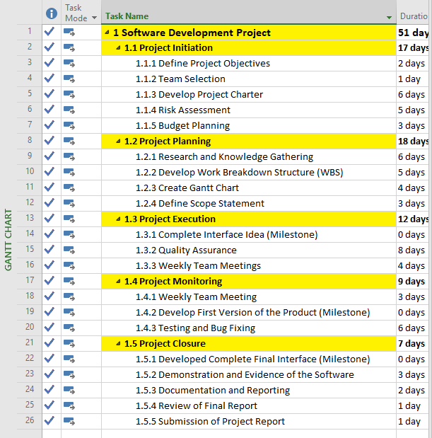

A- Project Execution Progress In GANTT CHART

### 

### B- Project Execution Progress In GANTT CHART

### 

This is the Timeline of the Complete Project of Software Development

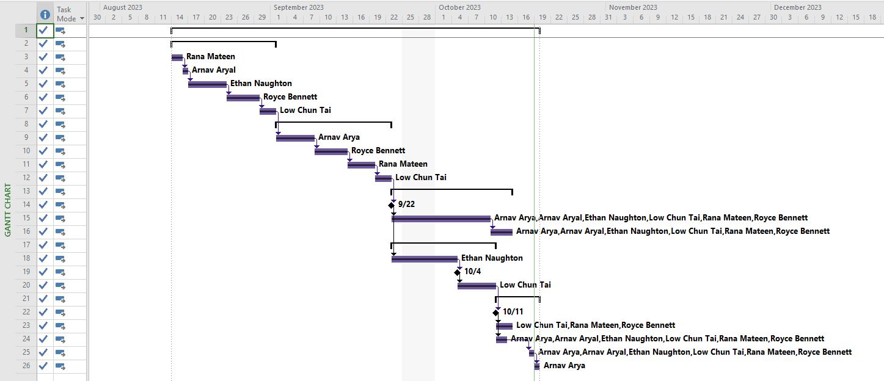

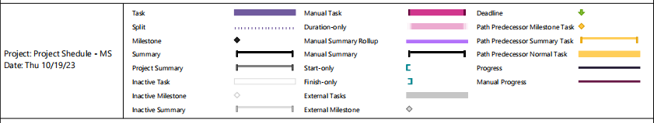

This is the GANTT CHART for Software Develeopement Project

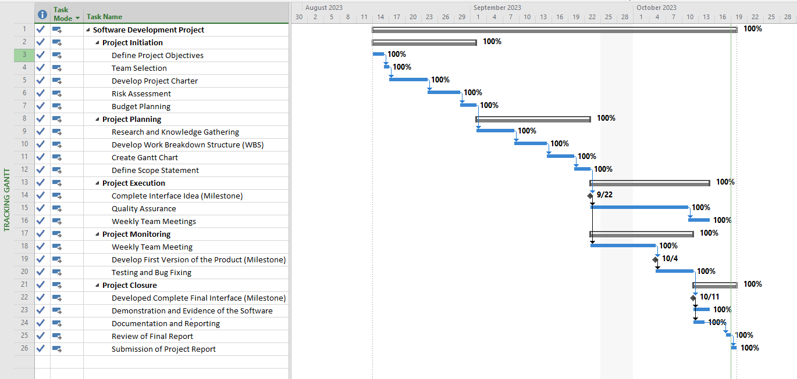

This is the Progress Tracking of the Project on GANTT CHART

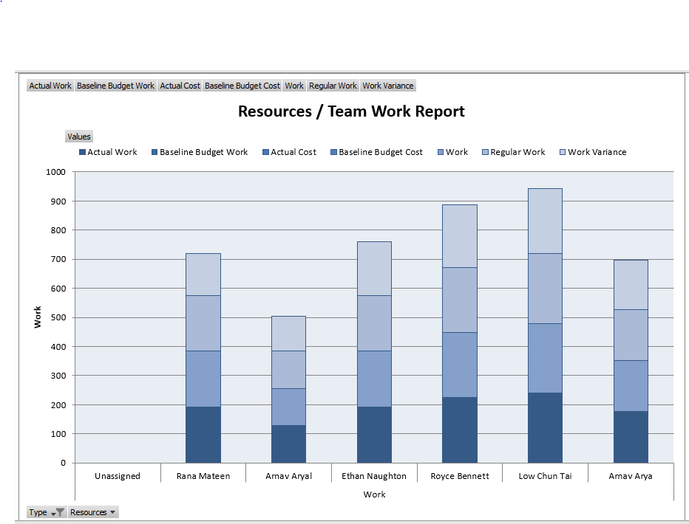

This is the Project Team / Recourses Report

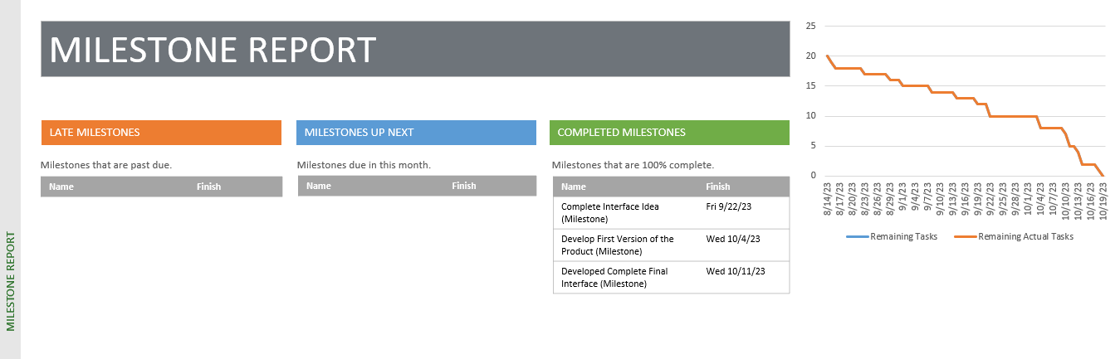

This is the Progress Milestones Report of Software Development Project

**WBS Dictionary**  
 1.1 Project Initiation  
 This will take 17 days  
  
 1.1.1 Define Project Objectives  
 The team comes together to work out what the project objectives are and have them outlined. This will ensure the team understands how the project will work. This will take 2 days  
  
 1.1.2 Team Selection  
 This will take 1 day. The 5 members have been given 2 tasks each for the documentation and will complete each task by the due date. Selection was based off what member was strong at and what they were happy to work on.  
  
 1.1.3 Develop Project Charter  
 This will take 6 days. Project charter will basically outline requirements, the circumstances and resources being used for the project. It’s a brief outline on what will happen and for a basic understanding of the project.  
  
 1.1.4 Risk Assessment  
 This will take 5 days. The risk assessment will outline all the risks that are possible within the project. This is important so each member knows what can occur and what can be done to stop and minimise these risks. This will ensure the project is done much more smoothly.  
  
 1.1.5 Budget Planning  
 This will take 3 days. This is important, so each member knows how much money they have to spend, and how much money will be set aside for the different expenditures.  
  
 1.2 Project Planning  
 This will take 18 days.  
  
 1.2.1 Research and knowledge gathering  
 This will take 6 days. Research is key so each member knows what they are working with. Researching other flight systems will give the members a better idea on how to develop the system and how they can do better than other companies.  
  
 1.2.2 Develop Work Breakdown Structure (WBS)  
 This will take 5 days. This is important so each major task is broken up into sub tasks which makes it easier to time manage and get things done one by one.  
  
 1.2.3 Create Gantt Chart  
 This will take 4 days. This will indicate how long each task will take and give the members a better understanding on the timeline for the project.  
  
 1.2.4 Define Scope Statement  
 This will take 3 days. This will outline the boundaries of the system and give the members a clear idea on the objectives and the main goal for the system.  
  
 1.3 Project Execution  
 This will take 12 days  
  
 1.3.1 Complete Interface Idea (Milestone)  
 Coming up with ideas will be important before starting off creating the system. Wireframes will be used to have a basic understanding on how each member will want the system to look like and function.  
  
 1.3.2 Quality Assurance  
 This will take 8 days. This will allow the members to know if the system is meeting or exceeding quality standards.  
  
 1.3.3 Weekly team meetings  
 This will take 4 days. Weekly meetings will allow the members to discuss about the project and see where everyone is up to do and what needs to be done. Goals will be set here.  
  
 1.4 Project Monitoring  
 This will take 9 days.  
  
 1.4.1 Weekly team meeting  
 This will take 3 days.  
  
 1.4.2 Develop First version of the product (Milestone)  
 This will allow the members to see if they are happy with how the product looks and if any adjustments and improvements can be made.  
  
 1.4.3 Testing and bug fixing  
 This will take 6 days. Testing the system is really important. Without testing, the system can not be accessible to the public as errors aren’t accounted for and the functions haven’t been checked properly.  
  
 1.5 Project Closure  
 This will take 7 days  
  
 1.5.1 Developed Complete Final interface (Milestone)  
 This will be the final interface that will be implemented out for the company and outside users to use.  
  
 1.5.2 Demonstration and Evidence of the software  
 This will take 3 days. This will allow users to know how the software works and what was actually used to create the system.  
  
 1.5.3 Documentation and reporting  
 This will take 2 days. This will outline everything that’s important about the system and the processes done to implement it and how it can be used.  
  
 1.5.4 Review of final report  
 1 day to make. This will give the full overview of the project.  
  
 1.5.5 Submission of project report  
 1 day

### 

This is the Project Overview Report

**Explanation:**

The project schedule and work breakdown structure (WBS) were first prepared in MS Project manually then shifted to auto-mode to ensure a well-structured execution plan for the Flight Online Service project. The schedule encompasses various key milestones and tasks, indicating their durations and dependencies, ensuring that every aspect of the project is accounted for. The project initiation phase, including team selection, charter development, and risk assessment, was allocated ample time to set a strong foundation. The project planning phase involved essential tasks such as research, WBS development, and Gantt chart creation to clearly outline the project's scope and progression. The execution phase, which encompasses significant milestones like interface development, quality assurance, and team meetings, was executed smoothly, with a strong focus on ensuring that the project adhered to its timeline. The project monitoring phase emphasized the importance of tracking progress through regular team meetings and testing, which contributed to quality control. Lastly, the project closure phase involved milestones like the final interface development, demonstration, and documentation, ensuring the project's successful completion. This meticulous planning and execution process facilitated a well-managed project that stayed on track and delivered results as envisioned.

### **Evidence of effective use of version control system:**

The evidence of effective use of a version control system, such as GitHub, for the Flight Online Service project is crucial for managing the development process. In this project, we can observe how version control played a vital role in ensuring efficient collaboration among the team members, tracking changes, and maintaining the integrity of the project. Throughout the project's timeline, the team created a repository on GitHub to store the project's source code and related documentation. By doing so, each team member could work on their assigned tasks and commit their changes to the repository. This allowed the team to keep track of who made what changes, when they were made, and provided the ability to roll back to earlier versions if necessary. Branches were utilized for different features or aspects of the project, ensuring that the development process remained organized and changes did not interfere with each other. The use of pull requests and code reviews in GitHub facilitated collaboration and ensured that changes were properly reviewed before they were merged into the main codebase, maintaining code quality and consistency. Additionally, GitHub provided a platform for issue tracking, which allowed the team to identify and address problems and enhancements efficiently. In conclusion, the effective use of GitHub as a version control system ensured that the Flight Online Service project progressed smoothly, with organized collaboration, version tracking, and quality control, contributing to the successful execution of the project.

### **Conclusion**

In conclusion, the Flight Online Service project, embarked upon by the team at FlyDreamAir, represents a remarkable effort to enhance the customer experience, operational efficiency, and revenue potential within the aviation industry. Through meticulous planning and execution, this project promises to revolutionize how customers interact with the airline, providing a user-friendly, efficient, and feature-rich platform for booking flights, managing reservations, and personalizing in-flight services. The well-structured project schedule, as evidenced in the Gantt chart, has set clear milestones and ensured that every aspect of the project was thoroughly considered. The effective use of a version control system, GitHub, allowed for seamless collaboration among team members, ensured version tracking, maintained code quality, and facilitated issue resolution. The project's justification was based on a comprehensive SWOT analysis, which revealed the project's potential to offer a competitive advantage, improve operational efficiency, and enhance the customer experience, outweighing potential threats and challenges. The software's benefits include higher customer satisfaction, operational cost savings, and increased ancillary revenue, while the cost estimation and feasibility studies highlighted the project's potential to yield a substantial return on investment.

With a clear project scope, work breakdown structure, and detailed roles and responsibilities, the team has set the stage for a well-organized development process. Moreover, the risk management strategy, focused on technical challenges, data security, competitive response, and user adoption, will help mitigate potential roadblocks along the way. As the project progresses through its various phases, from initiation and planning to execution, monitoring, and closure, it is evident that the team is committed to delivering a high-quality, user-centric software system that will drive FlyDreamAir's continued success in the dynamic aviation industry. By embracing technological innovation and adapting to evolving customer expectations, the Flight Online Service project promises to be a landmark achievement that sets the stage for sustained growth, efficiency, and customer satisfaction.

### 